

Semester One Examination, 2018

Question/Answer booklet

MATHEMATICS

SOLUTIONS
SPECIALIST
UNIT 1

Section One:

Calculator-free

Student number: In figures

In words

Your name

Time allowed for this section
Reading time before commencing work: five minutes
Working time: fifty minutes

Materials required/recommended for this section
To be provided by the supervisor
This Question/Answer booklet
Formula sheet

To be provided by the candidate
Standard items: pens (blue/black preferred), pencils (including coloured), sharpener,
correction fluid/tape, eraser, ruler, highlighters

Special items: nil

Important note to candidates
No other items may be taken into the examination room. It is your responsibility to ensure that you do not have any unauthorised material. If you have any unauthorised material with you, hand it to the supervisor before reading any further.

Structure of this paper

Section | Number of questions available | Number of questions to be answered | Working  time (minutes) | Marks available | Percentage of examination
Section One:  Calculator-free | 8 | 8 | 50 | 53 | 35
Section Two:  Calculator-assumed | 13 | 13 | 100 | 97 | 65
 |  |  |  | Total | 100

Instructions to candidates

1. The rules for the conduct of examinations are detailed in the school handbook. Sitting this examination implies that you agree to abide by these rules.

2. Write your answers in this Question/Answer booklet.

3. You must be careful to confine your response to the specific question asked and to follow any instructions that are specified to a particular question.

4. Supplementary pages for the use of planning/continuing your answer to a question
have been provided at the end of this Question/Answer booklet. If you use these pages to continue an answer, indicate at the original answer where the answer is continued, i.e. give the page number.

5. Show all your working clearly. Your working should be in sufficient detail to allow your answers to be checked readily and for marks to be awarded for reasoning. Incorrect answers given without supporting reasoning cannot be allocated any marks. For any question or part question worth more than two marks, valid working or justification is required to receive full marks. If you repeat any question, ensure that you cancel the answer you do not wish to have marked.

6. It is recommended that you do not use pencil, except in diagrams.

7. The Formula sheet is not to be handed in with your Question/Answer booklet.

Section One: Calculator-free 35% (53 Marks)
This section has eight (8) questions. Answer all questions. Write your answers in the spaces provided.

Working time: 50 minutes.

Question 1 (5 marks)
Relative to the origin $O$, points $A$ and $B$ have position vectors $-3i-2j$ and $i-4j$ respectively.

(a) Determine the unit vector $\hat{c}$, where $c=\vec{AB}$. (3 marks)
Solution
$$c=\left(\begin{matrix}1 \\ -4\end{matrix}\right)-\left(\begin{matrix}-3 \\ -2\end{matrix}\right)=\left(\begin{matrix}4 \\ -2\end{matrix}\right)$$

$$\left|c\right|=\sqrt{16+4}=2\sqrt{5}$$

$$\hat{c}=\frac{1}{2\sqrt{5}}\left(\begin{matrix}4 \\ -2\end{matrix}\right)=\frac{\sqrt{5}}{5}\left(\begin{matrix}2 \\ -1\end{matrix}\right)$$

Specific behaviours
vector $c$
magnitude
unit vector, simplified

(b) Vector $d$ has magnitude $3\sqrt{5}$, is parallel to $c$ and in the opposite direction. Determine $d$.
(2 marks)
Solution
$$d=3\sqrt{5}×\left(-1\right)×\frac{\sqrt{5}}{5}\left(\begin{matrix}2 \\ -1\end{matrix}\right) \\ =\left(\begin{matrix}-6 \\ 3\end{matrix}\right)$$

Specific behaviours
reverses $c$
correct vector

Question 2 (5 marks)
Let the displacement vectors $a, b$ and $c$ be $(11, -4)$, $(5, 14)$ and $(8, m)$ respectively, where $m$ is a constant.

(a) Determine the vector $3a+2b$. (2 marks)
Solution
$$3a+2b=3\left(11, -4\right)+2\left(6, 14\right) \\ =\left(33, -12\right)+\left(12, 28\right) \\ =(43, 16)$$

Specific behaviours
multiplies by scalar
correct vector

(b) Given that $\left|a+b+kc\right|=0$, detemine the values of $k$ and $m$. (3 marks)
Solution
$$\left(\begin{matrix}11 \\ -4\end{matrix}\right)+\left(\begin{matrix}5 \\ 14\end{matrix}\right)+k\left(\begin{matrix}8 \\ m\end{matrix}\right)=\left(\begin{matrix}0 \\ 0\end{matrix}\right)$$

From $i$-coeff: $11+5+8k=0⇒k=-2$

From $j$-coeff: $-4+14-2m=0⇒m=5$

Specific behaviours
vector equation
value of $k$
value of $m$

Question 3 (8 marks)
Consider the following statement about a simple (no edges that cross) polygon:

If it has an interior angle sum of 360°, then it is a square.

(a) Use a counter-example to explain why the statement is false. (2 marks)

Solution
A trapezium has an interior angle sum of 360° but is not a square.

Specific behaviours
names or draws any quadrilateral that is not a square
uses angle sum and fact that shape is not a square

(b) Write the converse statement and state whether it is always, sometimes or never true.
(2 marks)
Solution
If it is a square, then it has an interior angle sum of 360°.

The converse statement is always true.

Specific behaviours
writes converse
states always true

(c) Write the inverse statement and state whether it is always, sometimes or never true.
(2 marks)
Solution
If it does not have an interior angle sum of 360°, then it is not a square.

The inverse statement is always true.

Specific behaviours
writes inverse
states always true

(d) Write the contrapositive statement and state whether it is always, sometimes or never true. (2 marks)
Solution
If it is not a square, then it does not have an interior angle sum of 360°.

The contrapositive statement is sometimes true.
(eg true for triangle, false for any quadrilateral)

Specific behaviours
writes contrapositive
states sometimes true

Question 4 (6 marks)
(a) Determine the value of the constant $n$, given that the vectors $12i+nj$ and $5i-8j$ are perpendicular. (2 marks)
Solution
$$60-8n=0$$

$$n=\frac{15}{2}=7.5$$

Specific behaviours
equates scalar product to 0
solves for $n$

(b) The vectors $a$ and $b$ are such that $\left|a\right|=18, \left|b\right|=12$ and $a∙b=-33$. Evaluate

(i) $-2a∙3b$. (1 mark)
Solution
$$-33×-2×3=198$$

Specific behaviours
correct value

(ii) $\left(a+b\right)∙(b-a)$. (3 marks)
Solution
$$\left(a+b\right)∙\left(b-a\right)=b∙b-a∙a$$
$$={\left|b\right|}^{2}-{\left|a\right|}^{2} \\ ={12}^{2}-{18}^{2}$$
$$=\left(12+18\right)\left(12-18\right) \\ =30×-6=-180$$

Specific behaviours
expands
simplifies to difference of squares
correct value

Question 5 (7 marks)
(a) In the diagram below, the vertices of triangle $ABC$ lie on a circle with centre $O$. Given that $∠ABC=54°$, determine the values of $∠AOC$ and $∠OAC$. (2 marks)

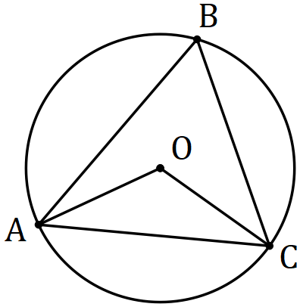
Solution
$$∠AOC=2×54=108°$$

$$∠OAC=\frac{180-108}{2}=36°$$

Specific behaviours
first angle
second angle

(b) Prove, assuming only basic axioms and properties of triangles, that the size of the angle subtended by an arc at the centre of a circle is twice the size of the angle subtended at any point on the circumference by the same arc. (5 marks)
Solution
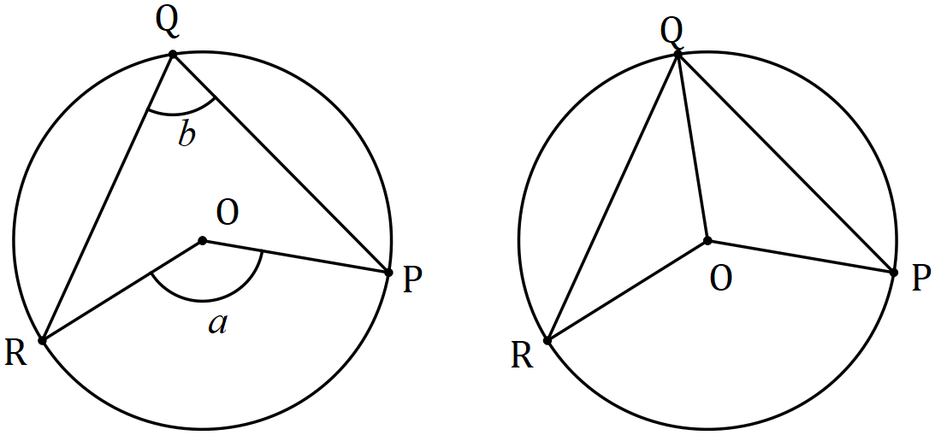

Required to prove that $a=2b$

Let $b=∠OQP+∠OQR$

But $∠OQP=∠OPQ$ and $∠OQR=∠ORQ$ (isosceles triangles)

And so $∠QOP=180-2∠OQP$ and $∠QOR=180-2∠OQR$

$$\text{At} O, a=360-∠QOP-∠QOR \\ a=360-\left(180-2∠OQP \right)-\left(180-2∠OQR\right) \\ a=2(∠OQP+∠OQR) \\ a=2b, \text{as required}.$$

Specific behaviours
labelled diagram(s) illustrating RTP
uses isosceles triangles
expressions for angles at $O$
equation using angle sum at a point
substitutes and simplifies

Question 6 (6 marks)
A drone leaves point $P$ and travels $115$ m on bearing of $340°$ to $Q$, then $30$ m on bearing $070°$ to $R$ and finally $85$ m on bearing $160°$ to $S$.

(a) Sketch a neat diagram to show the path of the drone. (2 marks)
Solution
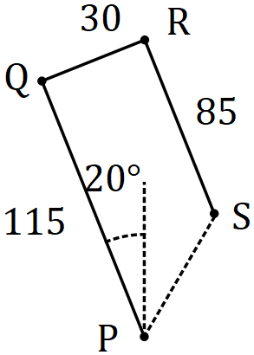

Specific behaviours
first leg, labelled
other legs and labels

(b) The drone is to return directly from $S$ to $P$. Determine the distance it must fly and on what bearing. (4 marks)
Solution
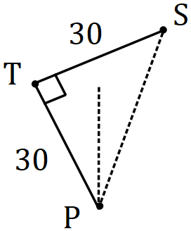 | $$PS=30\sqrt{2} \text{m}$$  $$∠SPT=45°$$  $$\text{Bearing is }180+\left(45-20\right)=205°$$
Specific behaviours
simplified sketch of return leg [or seen in (a)]
correct distance
indicates angle of $45°$ in triangle
correct bearing

Question 7 (9 marks)
(a) Evaluate $^{16}P_{11}÷ ^{14}P_{11}$. (3 marks)
Solution
$$\frac{16!}{5!}×\frac{3!}{14!}=\frac{16×15}{5×4}=12$$

Specific behaviours
expresses using factorials
eliminates factorials
evaluates

(b) Express $9!+8!+7!$ in the form $a^{2}b!$, where $a$ and $b$ are positive integers. (3 marks)

Solution
$$9!+8!+7!=\left(9×8+8+1\right)×7!$$
$$=81×7!$$
$$=9^{2}×7!$$

Specific behaviours
factors out lowest factorial
simplifies
writes in required form

(c) Show that for $n∈Z, n≥3$, the sum $n!+\left(n-1\right)!+\left(n-2\right)!$can always be expressed in the form $a^{2}b!$ where $a$ and $b$ are positive integers. (3 marks)
Solution
$$n!+\left(n-1\right)!+\left(n-2\right)!=\left(\left(n\right)\left(n-1\right)+\left(n-1\right)+1\right)\left(n-2\right)! \\ =\left(n^{2}-n+n-1+1\right)\left(n-2\right)! \\ =n^{2}\left(n-2\right)!$$

$$(a=n \text{and} b=n-2)$$

Specific behaviours
uses $\left(n-2\right)!$ as one factor
clearly shows composition of second factor
simplifies second factor and writes as required

Question 8 (7 marks)
In the diagram below, two chords of a circle, $BC$ and $DE$, intersect at $F$. $GB$ is perpendicular to $BC$ at $B$ and $GE$ is perpendicular to $DE$ at $E$. The line $GF$ intersects chord $CD$ at $H$.

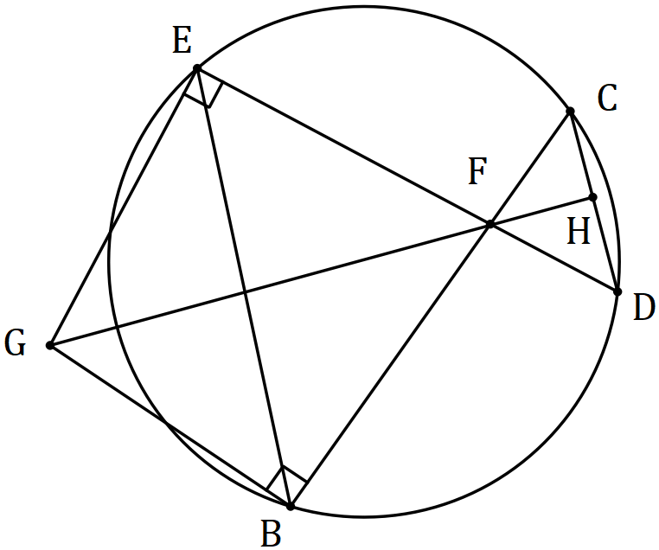

(a) Explain why $GEFB$ is a cyclic quadrilateral. (1 mark)
Solution
Sum of opposite angles $∠GEF+∠FBG=180°$.

Specific behaviours
explanation using opposite angles and their sum

(b) Prove that $∠CDE=∠EGF$. (3 marks)
Solution
$$∠CDE=∠CBE \text{(common arc} EC\text{)}$$

$$∠EGF=∠EBF \text{(common arc} EF)$$

$$\text{Hence }∠CDE=∠EGF \text{(since} ∠CBE \text{and} ∠EBF \text{are same angle)}$$

Specific behaviours
uses circle shown
uses circle from (a)
reasoning

(c) Prove that $GH$ is perpendicular to $CD$. (3 marks)
Solution
$$∠EFG=∠HFD \text{(Vert Opp)}$$
$$\text{Hence} ⊿EGF\sim ⊿HDF \text{(AA)}$$
$$∠FHD=∠FEG=90°⇒⊥$$

Specific behaviours
uses vertically opposite angles
uses AA for similarity
deduces perpendicular

Supplementary page

Question number: _________

© 2018 WA Exam Papers. Baldivis Secondary College has a non-exclusive licence to copy and communicate this document for non-commercial, educational use within the school. No other copying, communication or use is permitted without the express written permission of WA Exam Papers. SN261-111-2.

